Real Time Template
Juan M. Gago
Version 2 – June 14, 2007

Host PC Code (Visual C++)

This application obtains the echo of a static image of size 32 x 1024 32-bits pixels in real- time. Real-time means in this case that we continuously read from the same RAM position.

Firstly the Host PC downloads the image onto the memory of the DSP board. There, the master DSP will transmit it line by line (we assume a line transfer rate of 10KHz) to the slave processors. When the master DSP has received the echo-image from the slaves, the Host PC reads the result (we assume the data is ready after 1 second from the downloading, in others words, a frame rate of 1Hz).

FRAME_SIZE = 32 lines
LINE_SIZE = 1024 pixels

WHILE (!kbhit())

download_image
input = 1
sleep(1s)
upload_image

done = 1

Master DSP Code (VisualDSP)

If we implement a multiple buffer on the master DSP we could process a line while the new one is being downloaded from the SDRAM at the same time we could transmit the last processed result to a new PCI address.

DO
WHILE (!input)
input = 0

-----

read_line [next] // first line (offset = 0)

-----

read_line [next] // second line (offset = 1)
process_line [now]

-----

do
read_line [next]
process_line [now]
write_line [last]
while (1 < offset < FRAME_SIZE)

-----

process_line [now] // last line processing
write_line [last]

-----

write_line [last] // last line transmission

WHILE (!done);
Thanks to this technique, we do not lose time downloading and uploading data during each line period:

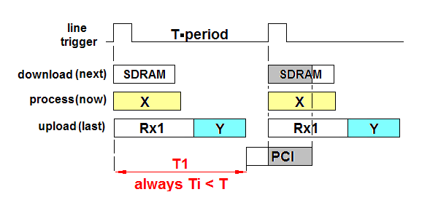
Figure 1 Chronogram

X: processing of a ¼ of a line, in parallel with the transmission of the other pieces to the slave processors. Fixed time.
Rx1: reception of the correspondent piece of line from the slave processors.
Variable time.
Y: transpose the pieces of line just received together with the ¼ of a line processed in the precedent line period. Fixed time.
PCI: transmission to the host-PC of the piece of line processed in the precedent line period

Timing of the BittWare Libraries

The next figure details the set up chosen to interconnect the different DSP’s.

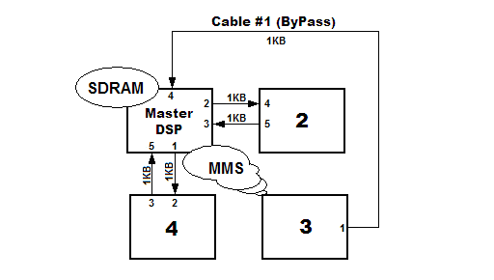
Figure 2 DSPs Interconnection

Library extint0.h: extmem_to_intmem(DMAC10) - intmem_to_extmem(DMAC11)

The extmem_to_intmem(DMAC10) function provides 4KB (size of a line) from the SDRAM each 100 us via DMA. We pretend in this way to simulate the line-capture by the camera at a programmed line-rate (10 KHz).

Data Input = 4KB @ 320 MB/s = 12.5 us

We have tested that preparing the transference of theses 4KB takes:

Data Input = (0x1E71 – 0x14FD) ×12.5 ns = 30.2 us*

The intmem_to_extmem(DMAC11) function writes 1KB on the MMS of the P3 processor. We have tested that preparing the transference of theses 1KB takes:

Writing to P3 MMS = (0x1E71 – 0x13E4) ×12.5 ns = 33.7 us*

Library linkdma.h : link_dma_noint_xmt(LINK3) - link_dma_noint_rcv(LINK2)

By using the Link Port (40MB/s) a transference of 1KB (4KB/4) takes theoretically 25.6 us.
Link Port = 25.6 us

We have tested that preparing the transference of theses 1KB between two processors by using link_dma_noint_rcv(LINK2) function takes:

Link Port Tx = (0x1E71 – 0x1616) ×12.5 ns = 26.7 us*

We have tested that the reception of 1KB by using link_dma_noint_xmt(LINK3) function takes:

Link Port Rx = (0x1616– 0x0E43) ×12.5 ns = 25.1 us

Library fin_pci.h : SharcFin_PCI_DMA_Write(DMAC12 or DMAC13)

After processing each line, we obtain 4KB of results stored in master DSP memory. We will charge them into the PCI memory of the Host PC by using a DMA channel of the cluster bus of the DSP board (320 MB/s)

Data Output = 4KB @ 320 MB/s = 12.5 us

The writing of the result from the intern memory toward the PCI memory will be implemented thanks to the SharcFin_PCI_DMA_Write function. This function returns the number of ticks of clock used to be completed. We have tested that preparing the transference of theses 4KB takes 34.8 us resulting a data-rate of about 132 MB/s.

Data Output = 2783 ×12.5 ns = 34.8 us

 | Data Input* | Writing To MMS P3* | Link Port Tx* | Link Port Rx | Data Output
Theoretically | 12.5 us | 3.1 us | 25.6 us | 25.6 us | 12.5 us
Real Test | 30.2 us | 33.7 us | 26.7 us | 25.1us | 34.8 us
Table 1. Summary of timing
* Time relative to the activation of the line trigger

The next figure synthesizes the data flow of the algorithm by using link ports and MMS.

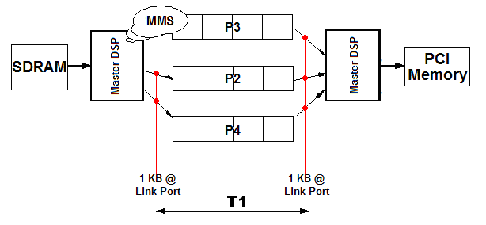
Figure 3 Data flow diagram between DSPs

T1 = (0x1E71 - 0x0E43) ×12.5 ns = 51.7 us < T = 100 us
ANNEX : Host PC Code (Diag21k script)

REM ===================================================================
REM run_sys.cmd
REM
REM This is a diag21k script file that can be run to test the
REM transfers using link port, SDRAM and MMS on a Hammerhead board.
REM
REM At a DOS prompt with executables HH1_GENERATOR.DXE and HHx_CONSUMER.DXE in
REM the local directory MYDIR\debug\, type:
REM
REM C:\MYDIR\>diag21k -xrun_sys
REM
REM ===================================================================

REM --------------------------------------------
REM Prepare and start PROC3, consumer
REM --------------------------------------------
br
bs 3
br
pc
mw ih 0x58000 0 0x4000
fl debug\hh3_consumer.dxe
mw li _Frame_Size 32
ps

REM --------------------------------------------
REM Load and start PROC2, consumer
REM --------------------------------------------
bs 2
pc
fl debug\hh2_consumer.dxe
mw li _Frame_Size 32
ps

REM --------------------------------------------
REM Load and start PROC4, consumer
REM --------------------------------------------
bs 4
pc
fl debug\hh4_consumer.dxe
mw li _Frame_Size 32
ps

REM --------------------------------------------
REM Load and start PROC1, the generator
REM --------------------------------------------
bs 1
pc
fl debug\hh1_generator.dxe
mw li _Line_Freq 10
mw li _Frame_Size 32
ps

REM --------------------------------------------
REM Free Run mode
REM --------------------------------------------
rem :LOOP
rem sp 1
rem mw li _input 1
rem goto LOOP

REM --------------------------------------------
REM Monitor PROC1 for completion
REM --------------------------------------------
echo Image ready?
os pause
mw li _input 1

echo Image ready?
os pause
mw li _input 1

echo Hit a key to stop:
os pause
mw li _done 1

echo PROC1 done, txpkts and offset
mr lh _frame_cnt
mr lh _txpkts
mr lh _rxpkts
mr lh _offset

REM --------------------------------------------
REM Link Port Buffers from P2 and P4
REM --------------------------------------------
echo For end of rcvd_P2[0] and beginning of rcvd_P2[1],
os pause
mr lh _rcvd_P2 0x101

echo For end of rcvd_P4[0] and beginning of rcvd_P4[1],
os pause
mr lh _rcvd_P4 0x101

REM --------------------------------------------
REM PROC2 status variables
REM --------------------------------------------
bs 2
mw li _done 1
echo
echo PROC2 done, txpkts and rxpkts:
mr li _done
mr lh _rxpkts
mr lh _txpkts

REM --------------------------------------------
REM PROC4 status variables
REM --------------------------------------------
bs 4
mw li _done 1
echo
echo PROC4 done, txpkts and rxpkts:
mr li _done
mr lh _rxpkts
mr lh _txpkts

REM --------------------------------------------
REM PROC3 status variables
REM --------------------------------------------
bs 3
mw li _done 1
echo
echo PROC3 done, txpkts and rxpkts:
mr li _done
mr lh _rxpkts
mr lh _txpkts

REM --------------------------------------------
REM PROC3 internal memory
REM --------------------------------------------
os pause
echo raw data on PROC3, buff0-buff1:
mr ih 0x580f0 20
os pause

REM --------------------------------------------
REM Check DMA metrics
REM --------------------------------------------
bs 1
echo For end of rcvd_P3[0] and beginning of rcvd_P3[1],
mr lh _rcvd_P3 0x101
os pause
echo STAT (TIMER INTR/DMAC11/LINK3):
mr lh _stat 20

ANNEX: Main loop on the Slave and Master Processor

MASTER  sbuf = 0; lbuf, rxbuf = 1; | SLAVE  txbuf = 0; rxbuf = 1;
Download_Line [sbuf]  Lnk2_TX [lbuf]  Lnk3_RX [rxbuf]  FFT [lbuf]  While (not RX from P2);  Upload_line [rxbuf] + FFT[sbuf]  sbuf ↔ lbuf  rxbuf++ % 2 | ----------  Lnk4_RX [rxbuf]  FFT [txbuf]  While (not RX from P1)  {}  Lnk5_TX [txbuf]  txbuf ↔ rxbuf  rxbuf++ % 2

